Curriculum Vitae

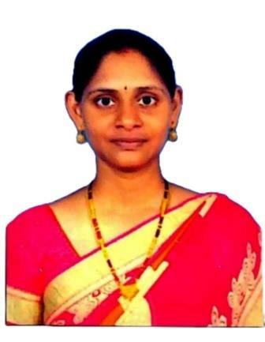
SRIDIVYA DANDAMUDI
M.tech,PhD from JNTUK(pursue)
Email: sridivyadandamudi@gmail.com
Phone:9441816050
Address : D-No-5-49, near vijaya super market,
gudlavalleru-521356,
Krishna (Dist), A.P

Career Objective:
To secure a challenging position where I can effectively contribute my skills in Teaching Professional, possessing competent Technical skills

Experience:

- Working as a Assistant Professor in Seshadri Rao Gudlavalleru Engineering College, Gudlavalleru-521356, Krishna Dist, Andhra Pradesh.
- Worked as a Lecturer in A.A.N.M & V.V.R.S.R Polytechnic, Gudlavalleru-521356, Krishna Dist, Andhra Pradesh.

- Worked as Co-ordinator of “ Online Question bank module “ in State Board of Technical Education and Training,Hyderabad,A.P.

Education Qualification:

- Pursue phD in Computer science and engineering from JNTUK started in 2022(through APRCET- Rank 34)
- M.Tech in Computer Science and Engineering 2012-14 from Sri Sai Jyothi College of engineering,ligampally,JNTUH with 79%
- B.Tech in Information Technology during 2006-10 from Nova college of Engineering,Ibrahimpatnam,JNTUK with 73%
- Intermediate from board of Intermediate with 92.6% during 2004-2006
- S.S.C from Board of Secondary Education with 87% during 2003-2004

Certificates:

- Received Nptel Domain Scholarcertificate in Programming domain in 2023
- Received Nptel Star certificate from Swayam in 2021
- Received Blue Prism Foundation trainee certificate in 2020

Workshops Attended:
- Attended for FDP on ANDROID APPLICATION DEVELOPMENT organised by APSSDC,AP.
- Attended for FDP on INTERNET OF THINGS(IOT) organised by APSSDC,AP
- Attended for FDP on PYTHON PROGRAMMING organised by APSSDC,AP
- Attented for FDP on DATA SCIENCES organised by AICTE TRAINING AND LEARNING(ATAL) ACADEMY
- Attended for FDP on ARTIFICIAL INTELLEGENCE organised by BRAIN 'O' VISION SOLUTIONS INDIA PVT.LTD
- Attended for FDP on DATA SCIENCE AND CLOUD COMPUTING organised by CHEBROLU ENGINEERING COLLEGE.
- Attended for FDP on CYBER SECURITY organised by JNTUK UNIVERCITY COLLEGE OF ENG.VIZIANAGARAM.

Subjects Taught:

- C Programming and Data structures
- Python programming
- Computer Fundamentals
- Database management systems
- Operating systems
- Computer Hardware and networking
- Advanced computer technologies
- C#.NET
- Web Designing
- Computer Organization.
- Industrial Management and Entrepreneurship

Project Details:
Name: Web Structure Reorganization to improve web navigation efficiency
Description:To help experienced users not to lose their orientation, structure stability is taken into consideration. Stability constraint can also help website designers control the maintaining effort of Web.

Personal Profile :

Name : D.Sridivya
DOB : 08-03-1989
Husband Name : G.Sudheerbabu
Languages known : Telugu, English,Hindhi
Mail Id : sridivyadandamudi@gmail.com
Hobbies : surfing net, Listening music, cooking, gardening
Marital status : Married

I hereby declare that all the information provided here is correct to the best of my Knowledge

Date: 24-2-2023 Signature
Place: Gudlavalleru Sridivya. Dandamudi

